SECONDARY SCHOOL IMPROVEMENT PROGRAMME (SSIP) JUNE 2017
HIGH RISK

GRADE 12

SUBJECT: LIFE SCIENCES

LEARNER SOLUTIONS

(Page 1 of 17)

SESSION 1 and 2: Genetics and Heredity

QUESTION 1
1.1 D
1.2 C
1.3 B
1.4 C
1.5 B
1.6 B
1.7 C (7x2) (14)
QUESTION 1. 2
1.2.1  1.2.2  1.2.3  1.2.4  1.2.5  1.2.6  1.2.7  1.2.5  1.2.9  1.2.10  1.2.11  1.2.12  1.2.13  1.2.14  1.2.15 | Complete dominance  Cloning  Locus  Discontinuous variation  Phenotype  Homologous/bivalent  Allele /Multiple alleles  Dihybrid cross  Haemophilia  Incomplete dominance  Sex linked  Homologous  Co dominance  Recessive  Monohybrid cross |  | (15)
QUESTION 1.3
1.3.1 | Both A and B
1.3.2 | B only
1.3.3 | B only
1.3.4 | None
1.3.5 | A only | (5X2)  (10)

QUESTION 1.4
1.4.1 | There are two characteristics being studied | (1)
1.4.2 | (a) ttnn | (1)
 | (b) TN; Tn; tN; tn | (2)
1.4.3 | Taste-blind with normal skin pigmentation | (2)
 |  | (6)

QUESTION 2
2.1 | (a)  (b) | X^{A}Y  X^{A}Xª | (2)  (2)  [4]
QUESTION 3
3.1  3.2 | (a) wwyy  (b) WY, Wy  Pea comb, yellow legs |  | (2)  (2)  (2)  [6]
QUESTION 4
4.1  4.2 | (a) homozygous dominantor heterozygous  (b) homozygous recessive  - Normal is dominant and the dominant condition  - can show up in either homozygous  - or heterozygous state  OR  - To have a normal child  - the person O must have at least one dominant gene  - phenotype is normal | (2)  (1)  (3)  [6]

QUESTION 5:
P₁ Phenotype: Blood group A x Blood group B

Genotypes I^{A}i x I^{B} i
meiosis
gametes I^{A} , i x I^{B} , i

 | I^{A} | i
I^{B} | I^{A}I^{B} | I^{B}i
i | I^{A}i | ii
fertilisation

F₁ Genotype I^{A}I^{B} I^{B}i I^{A}i ii
Phenotype, blood group: AB, B, A, O
[7]
QUESTION 6
6.1  6.2  6.3 | - Because they were normal they must each have one dominant  allele  - and in order for their children to be affected each parent must have  one recessive allele  NNor Nn  - The father would have been affectedif it was sex-linked  - in order for the daughter to be affected | (2)  (2)  (2)  [6]
QUESTION 7
7.1 | (a) GgTt  (b) Yellow leaves no thorns | (1)  (2)  [3]

QUESTION 8
P₁ Phenotype: Pink x Pink

Genotypes RW x RW
meiosis
gametes R , W x R , W

 | R | W
R | RR | RW
W | RW | WW
fertilisation

F₁ Genotype RR RW RW WW
Phenotype: Red, Pink, White
[6]
QUESTION 9:
9.1  9.2 | (a) BbTt  (b) Black coat short tail  (c) BbTt  0% | (2)  (2)  (1)  (1)  [6]

QUESTION 10:
10.1 | (a) Male with Tay Sachs disease /all 4 symptoms must be given  blind, deaf, mentally retarded and paralysed/lose motor skills and  mental functions  (b) Nn  (c) Nn | (2)  (2)  (2)  [6]

SECTION B: HOMEWORK SOLUTIONS

QUESTION 1:
1.1 | 3 |  | (1)

1.2 | P₁: Phenotype : Blood group A X Blood group B  Genotype : I^{A}i X I^{B}i  Meiosis  Gametes : I^{A} ; I^{A} ; i; i I ^{B}; I ^{B} ; i ; i  Fertilisation  F₁: Genotype : 25 % I^{A}I^{B}  25% I^{A}i  25% I^{B}i  25% ii  Phenotype:  25% Blood group AB  25% Blood group A  25% Blood group B  25% Blood group O  - indicating P₁ and F₁  - indicating meiosis and fertilisation Any 7 |  | (7)  [8]

QUESTION 2:
2.1  2.2  2.3 | When the gene that causes the disorder is located on the sex chromosomes/gonosomes  (a) Colour blind male  (b) Normal female  (a) X^{B}X^{b}  (b) X^{b}X^{b} | (1)  (1)  (1)  (1)  (1)  (5)

QUESTION 3:
3.1 | (a) Big and green fruit  (b) BG, Bg, bG, bg | (2)  (2)  [4]

QUESTION 4
4.1.1  4.1.2 | Two  bR , br |  | (1)  (2)

4.1.3 | (a)  (b)  (c) | Bbrr  White rough coat  3 black rough: 3 black smooth: 1 white rough: 1 white smooth  ( Ratio can be in any order) | (1)  (1)  (2)  [7]
  - QUESTION 5
5.1 | (a) normal female  (b) X ^{H} X ^{h} | (1)  (2)
5.2 |  | (3)  (13)

  - question 6
6.1. | P₁ Phenotype red apple tree X yellow apple tree  Genotype Rr X rr  Meiosis R; R; r; r r; r; r; r  F₁ Fertilization  R r  r Rr rr  r Rr rr  OR  F₁ Genotype 2x Rr; 2x rr  F₁ Phenotype 2 x red apple trees; 2 x yellow apple trees  P₁ and F ₁  Meiosis and fertilization (Any 6) | (6)
6.2 | 50% | (1)

SESSION 3: Nervous system
QUESTION 1:
1.1 A
1.2 C
1.3 A
1.4 B
1.5 C
1.6 B
1.7 C
1.8. B
1.9. C
1.10. A
1.11 C (11x2=22)

QUESTION 2.1:
2.1.1 Neurons
2.1.2 Peripheral nervous system
2.1.3 Parasympathetic nervous system
2.1.4 Multiple sclerosis
2.1.5 Cerebrospinal fluid
2.1.6. Medulla Oblongata
2.1.7. Meninges
2.1.8. Stimulus
2.1.9. Sensory neuron
2.1.10 Reflex arc (10 x 1 =10)

Question 2.2

2.2.1 None

2.2.2 A only

2.2.3 A only

2.2.4 B only (2 x 4 =8)

QUESTION 3:
3.1 C
3.2 B
3.3 A
3.4 A
3.5 B (5 x 1) [5]

QUESTION 4:
4.1. (a) Grey matter✓ (1)
(b) Interneuron✓/connector neuron (1)
4.2. (a) A ✓ (1)
(b) C ✓ (1)
[4]

QUESTION 5:
5.1 | Motor✓ /efferent/multipolar neuron. | (1)
5.2 | A – Dendrites ✓  B – Nucleus ✓  D – Axon✓ | (3)
5.3 | (a) A✓ - Dendrites✓   (b) D✓ - Axon. ✓   (c) C✓ – Myelin sheath✓  | (6)  [10]

QUESTION 6
 | Sensory Neurons | Motor Neurons
Structure | Unipolar (one pole) or bipolar (two poles) . | Multipolar with many dendrites
Function | Always conducts impulses  from the receptor (sense organ)  to the CNS (spinal cord and brain).  | Always conducts impulses  from the CNS (spinal cord and brain) to the effectors (muscles and glands) to bring about a response. 
[8]
QUESTION 7

7.1.1 A reflex action is a rapid, automatic response to a stimulus (2)

7.1.2. A- Sensory neuron (1)

B Interneuron/ connector neuron (1)

C- Motor neuron/efferent/multipolar (1)

7.1.3 (a) C (1)
(b) A (1)

7.1.4 It protects the body from dangerous situations (1)
(8)

QUESTION 8

8.1.1. (a) Medulla oblongata (1)
(b) Corpus callosum (1)
(c) Cerebellum (1)

8.1.2. –Controls all voluntary activities
-It contains centres that receives and interprets all the sensations
-it is the seat of higher mental functions
- Influences emotional behaviour (Any 3) (3)
(6)
QUESTION 9
9.1 | Motor✓ /efferent/multipolar neuron. | (1)
9.2 | – Transmits impulse away from the cell body ✓  – Transmits impulse to effector ✓  Any one | (1)
9.3  9.4 | - Causing it to conduct impulse faster✓/prevent a short circuit  - Insulates ✓ the neuron  - Nerve impulse will not be carried to the effector✓/muscle/gland  - There will not be a response✓ to the particular stimulus  | (2)  (2)  [6]

SECTION B: HOMEWORK SOLUTIONS

QUESTION 1:
1.1 (a) E (1)
(b) A (1)
(c) C (1)

1.2 F - motor neuron (2)

1.3 D to E (1)
[6]
QUESTION 2:

2.1 The reflex action: is a rapid automatic response to a stimulus that is
received by a sensory organ, to ensure a quick response.
The reflex arc: is the path travelled by the nerve impulses from the sensory neuron, through the connector neuron, to the motor neuron and then to the
effector.  Any 6 (6)

2.2 A reflex action allows the body to respond very quickly, to protect itself against possible injury, e.g.: pricking finger/ knee jerk reaction/ removing hand from a candle flame/hot stove plate etc.  (3)
[9]
QUESTION 3

3.1.1 A- Cerebrum
B- Cerebrum (2)

3.1.2. (a) B (1)
(b) C (1)
[4]

QUESTION 4

4.1.1. (a) Synapse (1)
(b) inter-neuron/connector neuron (1)

4.1.2. A B C (2)

4.1.3.

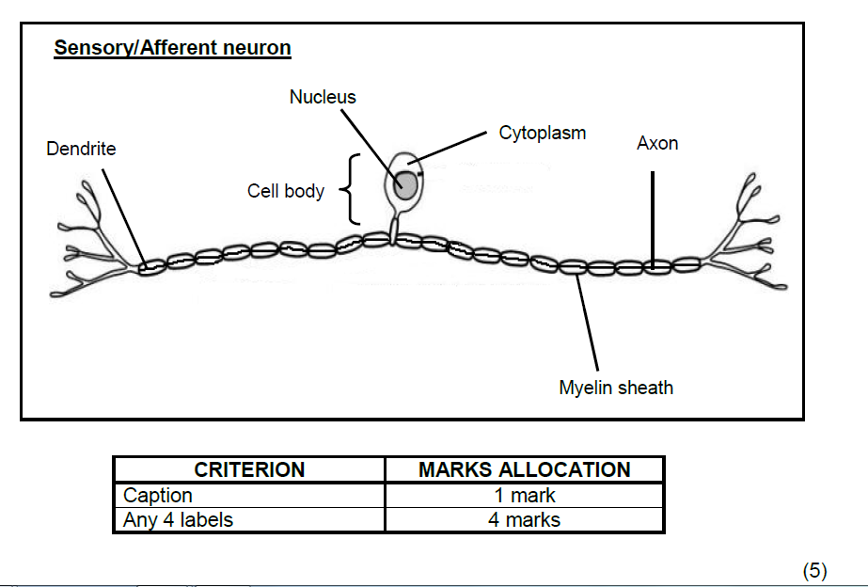
(9)
SESSION 4 and 5: EYE AND EAR

1.1
1.1.1. B
1.1.2. D
1.1.3. C
1.1.4. C
1.1.5. B
1.1.6. C
1.1.7. A
1.1.8. D
1.1.9. B
1.1.10 C 10 x2= (20)

1.2.
1.2.1. Grommets
1.2.2. Pinna
1.2.3. Aqueous humour
1.2.4. Choroid
1.2.5. Iris
1.2.6. Yellow spot
1.2.7. Ossicles
1.2.8. Cerebellum. (8)

1.3.
1.3.1. A
1.3.2. A
1.3.3. A
1.3.4. None
1.3.5. B
1.3.6. Both A and B
1.3.7. None
1.3.8. B 8x2=(16)

QUESTION 2:
2.1 B - tympanic membrane to vibrate and transfer the sound wave to the
Ossicles / hammer  (2)
C - malleus/hammer to vibrate and transfer the sound to the anvil
/amplify sound (2)
F – cochleato convert the stimulus of the sound waves into an
impulse                             (2)
2.2 Pinna has many ridges to direct the sound waves along the auditory
canal Extends outside the head / large flaps / funnel shapedto trap
sound waves  (Mark first answer only) (any 2) (2)
2.3 a) D    (1)
(b) A  (1)
(c) E     (1)
(d) G (1)
[12]

QUESTION 3:
3.1 | Diagram showing the ossicles ✓/middle ear | (1)
3.2 | A – Malleus/Hammer ✓  B – Auditory canal/meatus ✓ | (2)
3.3 | Structure C (Tympanum) is wider ✓in diameter than structure E/ (the oval window) ✓. This would cause sound to be amplified | (2)  [5]
QUESTION 4:
 | 4.1 | A – Ciliarymuscle/(body)  B – Iris  E – Choroid |  | (3)

 | 4.2 | (a) F  (b) D  (c) C  (d) A |  | (1)  (1)  (1)  (1)  [7]

QUESTION 5:
5.1 (a) Round window (1)
(b) Cochlea (1)
(c) Auditory nerve (1)
5.2 Cristae (1)

QUESTION 6:
6.1. a) A- ciliary muscle (2)
b) C – iris/ radial/circular muscles (2)
c) D – cornea (2)
6.2. Accommodation 2)

QUESTION 7:
7.1 | A - Pinna  D - Semi-circular canal |  | (2)

7.2 | (a)  (b)  (c)  (d)  (e)  (f)  (g)  (h) | B  G  F  C  E  D  E  B |  | (1)  (1)  (1)  (1)  (1)  (1)  (1)  (1)  (10)

QUESTION 8

a) B Sclera
b) D Cochlea
c) E Round window
d) A Iris
e) F Eustachian tube
f) C Auditory/Cochlear nerve/Vestibular nerve
(12)

QUESTION 9

9.1. Maculae (1)
9.2. Cristae (1)
9.3. Rods and cones (2)

QUESTION 10

10.1. Near vision (1)

10.2
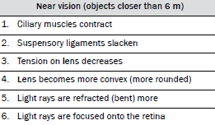 Any 5= (5)

QUESTION 11

11. 1. A - Tympanic membrane
D – Round window
E – Eustachian tube (3)

11.2. The Eustachian tube will not be able to equalise the pressure both
sides of tympanic membrane which will cause the membrane to
bulge/pain (2)

11.3. Hammer, anvil, stirrup (3)

SECTION B: HOMEWORK SOLUTIONS

QUESTION 1
1.1  1.2  1.3  1.4  1.5 | (a) Lens  (b) Choroid  Long-sightedness /hyperopia/hypermetropia  - Cannot see near objects clearly  - Causing the image to be blurred  - Since part A have no receptors present  - Light will not be converted into an impulse  - therefore no image will be formed /cannot see the object  - Lens is elastic  therefore can change shape /convexity/can allow for  accommodation  - Lens is transparent  to allow light rays to pass through  - Lens is biconvex  To refract light rays Any (2x2) |  | (1)  (1)(1)  (2)  (3)  (4)
QUESTION 2
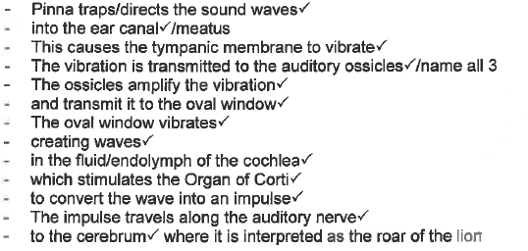(10)
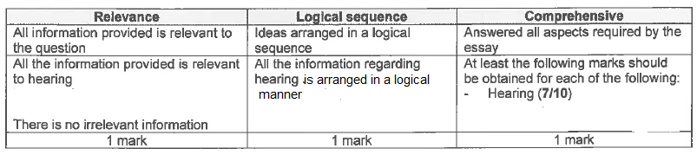

QUESTION 3
3.1  3.2  3.3 | (a) Semi-circular canals  (b) Eustachian tube  (c) Oval window /fenestra ovalis  - A/the tympanic membrane is larger/ larger surface area  - than D/the oval window /smaller surface area  - Therefore the incoming sound waves are concentrated onto a  smaller area  thus amplifying the sound  Allows ossicles/tympanum to vibrate freely |  | (1)  (1)(1)  (3)  (1)  (7)

SESSION 6: HUMAN ENDOCRINE SYSTEM

QUESTION 1:
1.1 - The blood glucagon levels increase /from 100 to 210  (picograms/ml)  - from 0 to 20 min  - and become constant thereafter  1.2 - during exercise more energy is needed  - therefore the rate of cellular respiration increased -  - Increased cellular respiration requires more glucose  - hence more glucagon is secreted  - to stimulate the conversion of glycogen to glucose Any | (3)  (3)

QUESTION 2:
2.1 0.25 g /cm3 (1)

2.2 15 Minutes (1)

2.3 - Blood glucose level of a person with diabetes mellitus is
higher than that of a normal person at all times
- There is a greater increase in the blood glucose level of a person
with diabetes mellitus after ingestion of glucose! compared to
the normal person
- It takes longer for the blood glucose level to stabilise
for the person with diabetes mellitus compared to a normal
person Any (2x2) (Mark first TWO only) (4)
[6]

QUESTION 3:
3.1 - Gland that secretes hormones
- directly into the blood /(rather than through ducts) (2)

3.2 (a) Insulin (1)
(b) Glucagon (1)

3.3 Pancreas /Islets of Langerhans (1)
[5]
QUESTION 4:

4.1 (a) Amount of thyroxin (1)
(b) Body weight (1)

4.2 - Same number of rats in each group
- All rats were of the same species
- All groups were investigated for the same period of time
- All rats were the same gender
- All groups were weighed after the same interval (Any 3) (3)

4.3 Group A (1)
[6]

SECTION B: HOME WORK SOLUTIONS

QUESTION 1:
- Hormones
- Pituitary gland / hypophysis
- Pituitary gland / hypophysis
- Endocrine
- Goitre
- Adrenal glands
- Diabetes
- Insulin
- Nervous system
- Adrenal glands
- Reflex action
- Thyroxin
- TSH
- Adrenalin
- Negative feedback (15 x 1) [15]

QUESTION 2:
2.1. a) 16:40 b) 09:00 (2)

2.2. a) 130 mg/10 cm³ blood b) 98 mg/100 cm³ blood (2)

2.3. a) 08:00 to 09:00 b) 16:00 to 17:00 (2)

2.4. a) 08:00 to 09:00 b) 15:00 to 16:00 (2)

2.5. After a meal rich in carbohydrates √, digestion takes place √ and glucose is absorbed into the blood stream √ thereby increasing √ the blood sugar level.
(4)

2.6. a) Insulin (1)
b) Beta cells √ of the Islets of Langerhans in the pancreas √ (2)

2.7. a) glucagon (1)
b) alpha cells √ of the Islets of Langerhans in the pancreas √ (2)

QUESTION 3:
3.1 Pituitary gland √ (1)

3.2 Mouse I √ (1)

3.3 - Growth hormone (GH) / Somatotrophic hormone (STH) √ (1)

3.4 - for the same time period √
- it showed a greater increase in mass √ (2)

3.5 Fourth / 4th √ month √ (2)

