LIFE SCIENCES: CONSOLIDATION TASK 2
GREEN – BASIC KNOWLEDGE
BLUE - UNDERSTANDING
RED - HIGHER ORDER

Topic: Reproduction in Humans and Vertebrates
SECTION A

1 Various options are provided as possible answers to the following questions. Choose the correct answer and write only the letter (A to D) next to the question number (1.1.1 to 1.1.5) in your WORK BOOK.

  - Below is a set of events following fertilisation in humans.

1. The embryo is embedded in the uterine wall in humans.
2. A zygote is formed in the Fallopian tube.
3. Cell division occurs to form a ball of several hundred cells.
4. The blastocyst remains free for several days in the uterus.

Which ONE of the following represents the correct order in which the above events occur?

A 2, 3, 4, 1
B 2, 1, 3, 4
C 3, 2, 4, 1
D 1, 3, 2, 4

1.2 Which ONE of the following is an advantage of the testes being held in the scrotum, outside the body cavity?

A More sperm can be stored in the scrotum.
B Sperm formation is more efficient at temperatures below the normal
body temperature.
C The testes are better protected in the scrotum than in the body cavity.
D There is more time for prostate secretions to be added to the sperm.

1.3 Which ONE of the following hormones is responsible for the development
of secondary male characteristics?

A FSH
B Testosterone
C Oestrogen
D Progesterone

1.4 In gamete formation in human females, each diploid cell forms …

A four diploid gametes.
B one diploid gamete.
C one haploid gamete.
D two haploid gametes.

1.5 Which ONE of the following refers to development in some birds where the
eggs hatch outside the body and the young are born immobile and totally
dependent on its parents?

A Vivipary and precocial development
B Ovipary and altricial development
C Vivipary and altricial development
D Ovipary and precocial development
(10)

2 Give the correct biological term for each of the following descriptions.
Write only the term next to the question number (1.2.1 to 1.2.8) in the
WORK BOOK.

2.1 The period of development of an embryo in the uterus between fertilisation
and birth

2.2 A stage in the development of humans in which the embryo consists of a layer
of cells surrounding a cavity

2.3 The gland in the male reproductive system of humans that produces an
alkaline fluid to counteract the acid environment of the vagina

2.4 The duct leading from the testis to the urethra in human males

2.5 The process by which the ovum is formed through meiosis in the ovary

2.6 The outermost extra-embryonic membrane surrounding the embryo

2.7 The blood vessel in the umbilical cord that carries blood rich in oxygen
and nutrients

2.8 The structure in the head of a sperm cell that contains enzymes,
which break down the membrane surrounding the ovum (8)

3 Indicate whether each of the statements in COLUMN I applies to A only, B only, both A and B or none of the items in COLUMN II. Write A only, B only, both A and B, or none next to the question number (1.3.1 to 1.3.6) in the WORK BOOK.

Number | Column I | Column II
3.1 | Type of development resulting in offspring that are capable of moving around soon after hatching | A: Precocial  B: Altricial
3.2 | Provides greater chances for the fusion of sperm and egg | A: External fertilisation  B: Internal fertilisation
3.3 | Characteristic of vivipary | A: Placenta is formed  B: Live offspring is born
3.4 | Embryo is nourished with yolk found in the egg | A: Ovipary  B: Vivipary
3.5 | Foetus is attached to the mother's uterus | A: Ovipary  B: Ovovivipary
3.6 | Young bird cannot feed independently after hatching | A: Precocial development  B: Altricial development
(12)
[30]
SECTION B

4.1 Study the diagram below and answer the questions that follow.
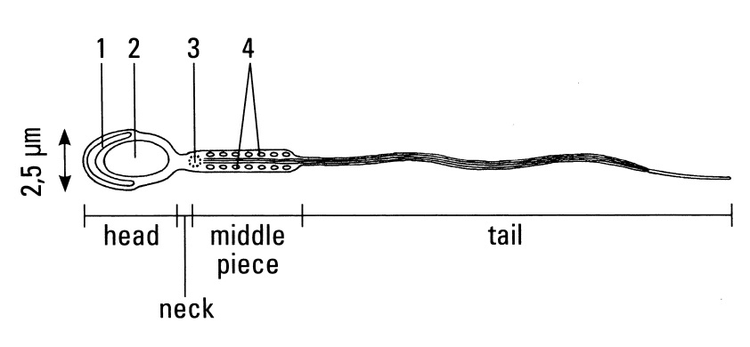
4.1.1 Give labels for the parts numbered 1 to 4. (4)

4.1.2 Calculate the magnification of this drawing. (3)
[7]

4.2 The diagram below represents the events leading to the development of the
foetus in the human uterus.

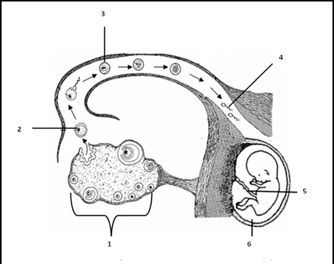

4.2.1 Provide labels for 1, 5 and 6. (3)
4.2.2 Explain the process from the formation of the zygote until the
implantation of the blastocyst in humans. Also describe the
difference between an embryo and a foetus. (20)
[23]
GRAND TOTAL: 60

MEOMORANDUM

SECTION A

1.1 A √√
1.2 B √√
1.3 B √√
1.4 C √√
1.5 B √√ (10)

2.1 Gestation √
2.2 Blastocyst √
2.3 Prostate gland √
2.4 Vas deferens √
2.5 Oogenesis √
2.6 Chorion √
2.7 Umbilical vein √
2.8 Acrosome √ (8)

3.1 A only √√
3.2 B only √√
3.3 A and B √√
3.4 A only √√
3.5 None √√
3.6 B only √√ (12)
[30]
SECTION B

4.1 1 acrosome √
2 nucleus √
3 centriole √
4 mitochondria √ (4)

4.1.2 2,5 µm represents 8 mm √
0, 0025 mm represents 8 mm √
Magnification = 8/0,0025 = 3200 times √ (3)
[7]
4.2.1 1 Ovary √
5 Umbilical cord √
6 Amniotic fluid √ (3)

4.2.2 zygote immediately divides by means of mitosis √ to form two identical√
cells, then four cells, eight cells, and so on until a ball of cells √ is formed called a morula √ continues to divide and after about 3 – 7 days it reach
the uterus, √ it is then a hollow ball of cells called a blastocyst √ which consists of an inner cell mass √ and an outer layer of cells √ known as
the trophoblast √ with a blastocyst cavity. √

The blastocyst remains in the uterus for about 2 to 5 days before it is implanted in the endometrium √ the trophoblast cells secrete enzymes
that breaks down the epithelium √ of the endometrium, the blastocyst becomes embedded in the endometrium √ this process is called
implantation Due to the actions of oestrogen and progesterone √ the endometrium is thick and very vascular√

The trophoblast develops finger-like villi (projections) √ that grow √ into
the endometrium. These villi together with the maternal endometrium √
form the placenta √ As the blastocyst develops the trophoblast forms
several membranes around the embryo√ – extra embryonic membranes √

As soon as all the organs are differentiated√/formed the embryo has then
developed into a foetus√ (after the ninth week)
Max (20)
[23]

GRAND TOTAL: 60

