
AHMED TIMOL SECONDARY
LIFE SCIENCES
EXAMINER: A. Rajah
MODERATORS: N. F. Maximilian & M. A. Khan
Marks: 150
Time: 2 Hours
GRADE 11
PAPER 1

NOVEMBER 2014

NOVEMBER 2011

THIS QUESTION PAPER CONSISTS OF 12 PAGES
INSTRUCTIONS AND INFORMATION
- Answer ALL questions on the writing material provided.
- Write neatly using a blue pen.
- Rule off after each question.
- ALL drawings should be done in pencil and labelled in blue ink.
- Only draw diagrams or flow charts when requested to do so.
- If answers are NOT presented according to the instructions of each question, you will lose marks.
- This question paper consists of 12 pages including this cover page

SECTION A

QUESTION 1

1.1 | Various options are provided as possible answers to the following questions. Choose the correct answer and write only the letter (A to D) next to the question number (1.1.1 to 1.1.10) in your ANSWER BOOK, for example  1.1.11 D.

 | 1.1.1 | Site of aerobic respiration.

 |  | A  B  C  D | Mitochondrion  Chloroplast  Ribosome  Cytoplasm

 | 1.1.2 | Hydrogen and oxygen combine to form water.

 |  | A  B  C  D | Hydrolysis  Glycolysis  Kreb’s cycle  Oxidative phosphorylation

 | 1.1.3 | Which of the following is a similarity between aerobic and anaerobic respiration?

 |  | A  B  C  D | Produce the same amount of ATP  Both require oxygen  Produce the same amount of alcohol  Both require glucose

 | 1.1.4 | Number of premolars in normal humans

 | A  B  C  D | 1  2  3  8

 | 1.1.5 | Swollen belly and stick like limbs as a result of a diet high in carbohydrates, but low in protein

 | A  B  C  D | Kwashiorkor  Marasmus  Anorexia  Bulimia

 | 1.1.6 | Study the diagram below showing various parameters that influence the size of a population.

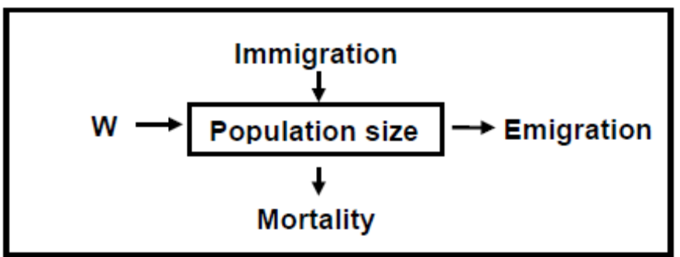

Which ONE of the following parameters is indicated by permanent
movement W?

 | A  B  C  D | Migration  Natality  Predation  Competition

QUESTIONS 1.1.7 AND 1.1.8 ARE BASED ON THE INFORMATION BELOW.
Population size can be estimated using the formula below:
P = population estimate
M = number of organisms captured and marked
C = number of organisms recaptured (second capture)
R = number of marked organisms in second capture

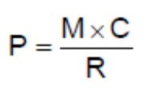

In an investigation to estimate the fish population in a certain dam, the following data was obtained:
Fish captured, marked and released = 40
Marked fish in the second capture = 12
Unmarked fish in the second capture = 48

 | 1.1.7 | The estimated size of the fish population is ...

 | A  B  C  D | 1 920  160  200  100

 | 1.1.8 | The validity of the investigation could be decreased if the…

 | A  B  C  D | investigation was repeated and the average estimate calculated.  mark used was harmless to the fish.  second capture was done very long after the first capture.  investigation was not repeated.

 | 1.1.9 | Carries blood with a high concentration of nitrogenous waste to the kidney

 | A  B  C  D | Renal artery  Renal vein  Ureter  Urethra

 | 1.1.10 | By-product of photosynthesis

 | A  B  C  D | Glucose  Oxygen  Carbon dioxide  light |  | (20)

1.2 | Give the correct biological term for each of the following descriptions. Write only the term next to the question number (1.2.1 to 1.2.8) in your ANSWER BOOK.

 | 1.2.1  1.2.2  1.2.3  1.2.4  1.2.5  1.2.6  1.2.7  1.2.8 | Cartilaginous flap that prevents choking while swallowing.  Hormone responsible for body salt balance  Thin breathing muscle found under the lungs  Gas required for normal cellular respiration in humans  Organelle wherein photosynthesis occurs  Phase of photosynthesis that takes place in the stroma  Population growth form characterised by a J-shaped curve  Symbiotic relationship between two organisms where both benefit |  | (8)

1.3 | Indicate whether each of the statements in COLUMN I applies to A ONLY, B ONLY, BOTH A AND B or NONE of the items in COLUMN II. Write A only, B only, both A and B, or none next to the question number (1.3.1 to 1.3.8) in the ANSWER BOOK.

 |  |  | COLUMN I |  |  | COLUMN II
 | 1.3.1 |  | Product of anaerobic respiration in animals |  |  | A: Ethanol  B: Lactic acid
 | 1.3.2 |  | Controls blood sugar level |  |  | A: Insulin  B: Glucagon
 | 1.3.3 |  | Excretes water |  |  | A: Kidney  B: Skin
 | 1.3.4 |  | Treatment of renal failure |  |  | A: Dialysis  B: Kidney transplant
 | 1.3.5 |  | Alveoli lose their elasticity |  |  | A: Hay fever  B: Asthma
 | 1.3.6 |  | Double membrane of the lung |  |  | A: Pleura  B: Renal capsule
 | 1.3.7 |  | Combines with CO₂ to form glucose during photosynthesis |  |  | A: ADP  B: ATP
 | 1.3.8 |  | Group of organisms of the same species in the same area at the same time |  |  | A: Population  B: Community
 |  |  |  |  | (8 x 2) |  |  |  | (16)

1.4 | The diagram below represents an alveolus and its blood capillary.  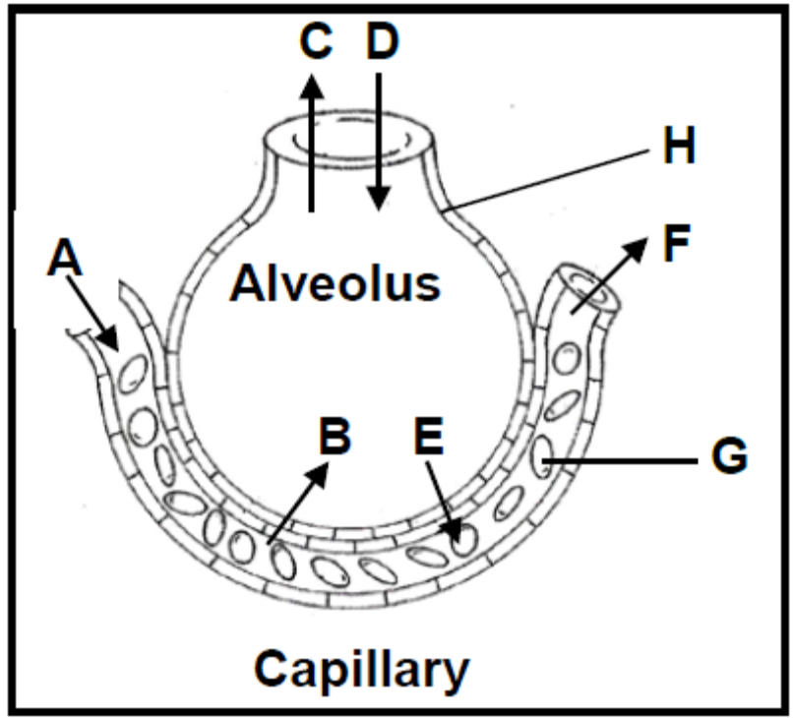  Indicate the LETTER(S) on the diagram which represents each of the following. Write only the letter (A to G) next to the question number (1.4.1 to 1.4.5) on the ANSWER SHEET, for example 1.4.6 H.

 | 1.4.1  1.4.2  1.4.3  1.4.4 | Cell(s) that carries oxygen and some carbon dioxide.  A thin layer of cells that allows for easy diffusion of gases.  Arrow(s) indicating the direction of movement of carbon dioxide molecules.  Area(s) with the highest oxygen concentration in the blood. |  | 6

TOTAL SECTION A: |  | 50

SECTION B

QUESTION 2

2.1 | The graph below shows changes in population numbers of rabbits and lynx  (member of the cat family) over 80 years. Study the graph carefully and  then answer the questions, which follow.

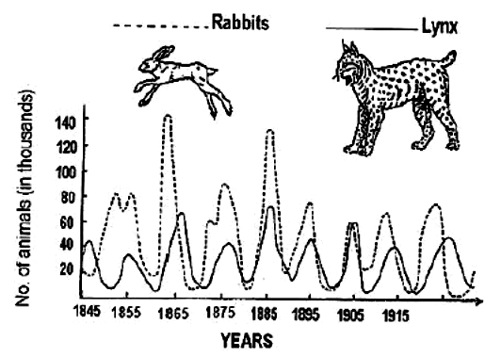

 | 2.1.1  2.1.2  2.1.3  2.1.4  2.1.5  2.1.6  2.1.7  2.1.8 | State the term that is used to describe the relationship between the  rabbit and the lynx.  How many of the following animals were present in 1885?  (a) Rabbits  (b) Lynx  What happens to the number of lynx when the rabbit population  increase?  Explain the reason for the change in numbers mentioned in 2.1.3.  What effect did the large number of lynx have on the rabbit  population?  Name two other factors that can reduce the rabbit population.  In an energy pyramid with three trophic levels (producers, primary  consumers and secondary consumers), which trophic level will  represent the lynx?  In which year was the rabbit population the highest? |  | 2  1  1  1  2  1  2  1  1  (12)

2.2 | Study the diagram below and answer the questions that follow  ORGANELLE A  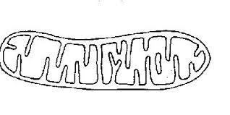  X ORGANELLE B Y  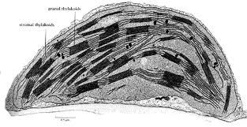

 | 2.2.1  2.2.2  2.2.3  2.2.4  2.2.5  2.2.6  2.2.7  2.2.8  2.2.9  2.2.10 |  | Name organelle A and organelle B.  Name the processes that take place in organelle A and organelle B respectively.  Which of these organelles occurs in both plants and animals.  Name the type of organic compound transferred as shown by arrow X.  Name the gas transferred between the organelles (shown as arrow Y)  Name TWO structural similarities between these two organelles.  Describe how organelle A is suited to its function.  Name a tissue where organelle A will be found in large numbers.  Name a part of the plant where it is unlikely to find any of organelle B.  Give a reason for your answer in 2.2.9 | 2  2  1  1  1  2  2  1  1  1
 |  |  |  | (14)
2.3 |  | The diagrams below represent graphs of age and gender distribution for a developed country and a developing country.  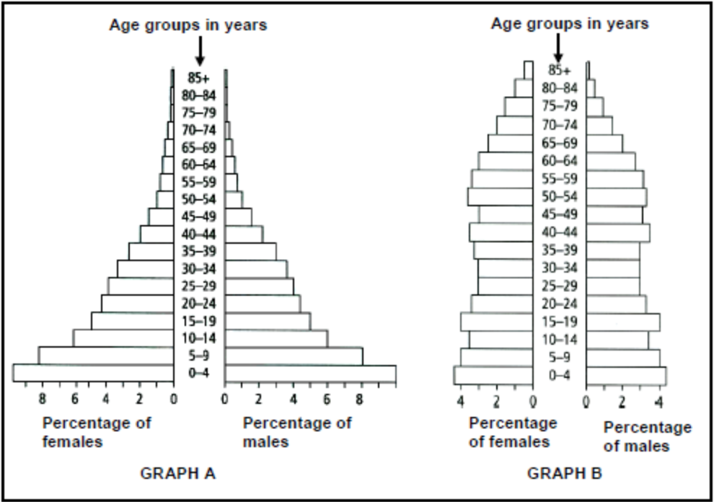

 | 2.3.1  2.3.2  2.3.3  2.3.4 | Which graph (A or B) represents the population distribution of a developing country?  Give TWO reasons for your answer to QUESTION 2.3.1.  Explain the value of the information provided by the graphs above when planning for education.  State TWO effects that a high population growth has on the environment. |  | 1  2  2  2  (7)
2.4 Read the passage below and answer the questions that follow.


 | 2.4.1  2.4.2  2.4.3  2.4.4 | State a method that is used to determine the human population size.  From the passage above, give TWO reasons why the Chinese government decided it was necessary to slow down the population growth rate.  Explain how the one-child policy can influence the population size over many generations.  In a country that values the birth of a son more than that of a daughter, explain how the one-child policy could influence the gender structure of the population. |  | 1  2  2  2(7)
QUESTION 3

3.1 | The model below shows a portion of the ribcage and its associated muscles in the human body. Study the model and answer the questions that follow. Note “dorsal” in humans will refer to the back and ‘ventral’ the front since we stand on two legs not four.  Front Surface  Back Surface

 | 3.1.1  3.1.2  3.1.3  3.1.4 | Identify bones A, B and C  Which parts of the breathing process are represented by D (solid lines) and E (broken lines) respectively.  Describes what happens to the volume of the thorax as it changes from sub-processes D to E.  Explain the significance of this volume change mentioned in question 3.1.3. |  | 3  2  1  4  (10)
3.2 | The human body loses water in several ways. The pie chart below shows the volume of water lost, in cm³, by a man on a cold day.

 | 3.2.1  3.2.2 | The total volume of water lost by the man was 3 000 cm³. Calculate the volume of water lost through the skin on that day.  Describe how the amount of water is regulated by the kidney on a cold day when there is excess water. |  | 3  8  (11)
3.3 | Draw a labelled diagram of the malpighian body of the kidney and its associated blood vessels. |  |  | (5)

3.4 | A group of grade 11 learners conducted an experiment on the rate of photosynthesis.  - A 10 cm length of pond weed was cut and placed in a test tube.  - A lamp was switched on facing the direction of the test tube.  - A beaker of water was placed in between the test tube and the lamp  to absorb heat but allow light to pass.  - The test tube was moved to a new position (distance from lamp) and left for 2 minutes.  - The number of bubbles released was counted.  The setup of the apparatus is shown below  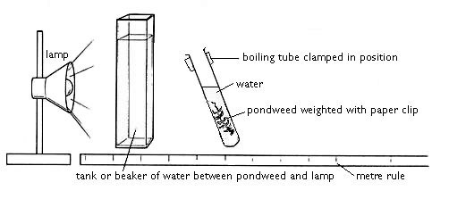  Boiling tube clamped in position  Water  Pondweed weighted with a paper clip  lamp  Beaker of water  Metre ruler  The results obtained are shown below
  Distance from lamp (cm) | Number of bubbles produced per minute
  10 | 28
  20 | 25
  30 | 20
  40 | 12
  50 | 4

 | 3.4.1  3.4.2  3.4.3  3.4.4  3.4.5 | Draw a line graph to represent the data in the table.  Describe the relationship between the two variables.  Suggest TWO ways in which the reliability of the experiment could be improved.  Suggest TWO ways in which the validity of the experiment could be improved.  Predict the consequences if the beaker of water that prevented heat transfer was not included in the investigation. |  | 6  2  2  2  2  (14)

TOTAL SECTION B: |  | 80

SECTION C

QUESTION 4

4. | Describe the processes of mechanical and chemical digestion in human nutrition. |  | (17)  (3)  (20)

 | NOTE: | NO marks will be awarded for answers in the form of flow charts or diagrams.

TOTAL SECTION C:  GRAND TOTAL: |  | 20  150



