# 

**GAUTENG WEST**

**LIFE SCIENCES**

**GRADE 11**

**PAPER 2**

**OCT/NOV 2015**

**TOTAL: 150 marks Time: 2 $\frac{1}{2}$ hours**

**INSTRUCTIONS AND INFORMATION:**

**Read the following instructions carefully before answering the questions:**

1. Answer **ALL** the questions.
2. Write **ALL** the answers in the ANSWER BOOK provided.
3. Write neatly and legibly.
4. Number the questions correctly according to the numbering system used in this question paper.
5. If answers do NOT follow the instructions of each question, candidates will lose marks.
6. ALL drawings should be done in pencil and labelled in blue ink.
7. Only draw diagrams or flow charts when asked to do so.
8. The diagrams in this question paper are not necessarily drawn to scale.
9. The use of graph paper is NOT permitted.

10. Non-programmable calculators, protractors and compasses may be used.

**SECTION A**

**QUESTION1**

* 1. **Various possible options are provided as answers to the following questions. Choose the answer and write only the letter (A-D) next to the question on your folio paper, for example 1.1.11 A.** 
     1. A biologist discovered a new living cell with a distinct cell wall, but no definite nucleus. The cell is likely to be of a/ an ……..

1. virus.
2. plant.
3. bacterium.
4. animal.
   * 1. Some members of the group fungi are...
5. photosynthetic.
6. chemosynthetic.
7. composted.
8. saprotrophic.
   * 1. The part of the flower that attracts insects.
9. Carpels
10. Anthers
11. Sepals
12. Petals
    * 1. Which of the following is a characteristic of all Protists?
13. Eukaryotes
14. Unicellular
15. Multicellular
16. Heterotrophic
    * 1. Which of the following characteristics apply to the Platyhelminthes?
17. Asymmetrical
18. Coelomate
19. Blind gut
20. Diploblastic
    * 1. The important bacteria living in the intestines of all humans are……
21. *E. coli*
22. *Lactobaccillus*
23. *Acetobacter*
24. *B. anthractis*
    * 1. Which part is not a part of the sporophyte generation of the Pteridophyte?
25. Frond
26. Rhizoids
27. Rhizome
28. Adventitious roots
    * 1. The acellular organisms which are responsible for spreading diseases are :
29. Fungi
30. Viruses
31. Bacteria
32. Algae
    * 1. Name the causative agent in malaria:
33. Humans
34. Water
35. Anopheles
36. Plasmodium
    * 1. Spores:
37. Produce new fungi
38. Are the roots of a fungi
39. Are male gametes of fungi
40. Are female gametes of the fungi

**10 x 2 = 20**

* 1. **Give the correct biological term for each of the following descriptions. Write only the term next to the question number.**
     1. The simples land plant without a cuticle.
     2. The dominant generation in angiosperms.
     3. All seed bearing plants.
     4. Plants without roots, stems and leaves.
     5. Animals that remain attached to a substrate for most of their lives.
     6. Seed – bearing plants with naked seeds.
     7. The variety of live on Earth.
     8. Species living in a habitat in which they are not naturally found.
     9. A type of reproduction that does not involve the fusion of male and female gamete.
     10. A measure of the total greenhouse gas emissions by an individual, company or a country per year.

**10 x 1 =10**

1.3 Indicate whether each of the statements in COLUMN I, applies to A only, B only, both A and B or None of the items in COLUMN II. Write A only, B only, both A and B or none next to the relevant question number.

|  |  |  |
| --- | --- | --- |
|  | **COLUMN I** | **COLUMN II** |
| 1.3.1 | Forms when the permeable rock layer becomes saturated with water | A Reservoir  B Aquifer |
| 1.3.2 | Reduction in ground cover and an increase in soil erosion | A Desertification  B Overgrazing |
| 1.3.3 | Individuals of a species that survive only in captivity | A Endanger  B Vulnerable |
| 1.3.4 | Removal of an alien species by hand | A Mechanical control  B Biological control |
| 1.3.5 | The process whereby water is boiled and treated | A Purification  B Filtration |
| 1.3.6 | Making products from materials that have been used before | A Reduce  B Recycle |
| 1.3.7 | A radioactive substance harmful to humans | A Methane  B Uranium |
| 1.3.8 | The illegal capture of animals or removal of plants | A Poaching  B Culling |
| 1.3.9 | Using water to generate energy | A Hydro-electric power  B Solar energy |
| 1.3.10 | A substance that can be recycled and reused | A Coal  B Glass |

**10 x 2 = 20**

**TOTAL SECTION A: 50**

**SECTION B**

**QUESTION 2**

2.1 Read the interview and then answer the questions.

**Emmanuel Tshikalange** is a researcher and PhD student at the University of Pretoria. He is working on the use of indigenous plants to cure diseases such as sexually transmitted infections (STIs) and HIV/AIDS.

**Dr Namrita Lall** is a lecturer and researcher in the Botany department at the University of Pretoria. She is working on a tuberculosis research project.

**South Africa has good doctors and we are doing excellent medical research.Why do people still visit traditional healers?**

*Emmanuel:* I come from a rural area where many people suffer from STIs. They trust traditional healers, and will rather go to a traditional healer than to a medical doctor.

**Do traditional healers really help patients?**

*Emmanuel:* Definitely, yes. My Master’s degree has shown that traditional healers are very successful in treating STIs. I worked with traditional healers and we looked at the active compounds in the *Senna* genus.

*Namrita:* Yes. Research on medicinal plants is getting a lot of attention in South Africa. The wealth of information on plants and the enormous diversity of South African flora (about 24 000 species), focused our attention on the use of medicinal plants. My research involves finding active ingredients in plants that can fight TB.

2.1.1 What is meant by saying a plant is indigenous? (2)

2.1.2 What does the acronym STI stand for? (2)

2.1.3 What does *Namritas*research involve? (2)

2.1.4 Explain briefly what traditional healers do. (2)

2.1.5 What causes TB? (2) **(10)**

2.2 Study the diagram below and answer the questions that follow.

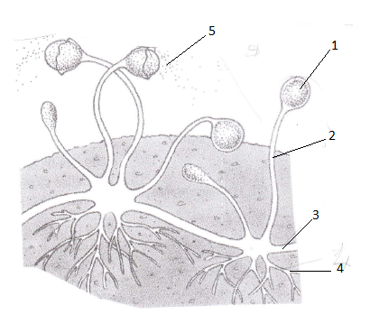

2.2.1 To which kingdom does this structure belong? (2)

2.2.2 Identify the structure in the diagram above. (2)

2.2.3 What type of nutrition does this structure have? (1)

2.2.4 Identify labels numbered 1 to 5. Use numbers when answering. (5) **(10)**

2.3 Study the diagrams below and answer the questions that follow.

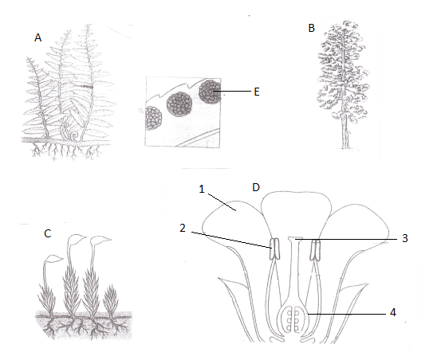

2.3.1 Identify the plant groups to which plant A and C belong. Use letters when

answering. (2)

2.3.2 Identify label E and what is kept in it. (2)

2.3.3 Name FOUR ways in which plant B is similar to plant D. (4)

2.3.4 Plant A is more terrestrially adapted than plant C. Explain this statement. (4)

2.3.5 Identify the numbered labels as shown in diagram D. (4)

**(16)**

2.4 Name FOUR ways in which flowers are adapted to be wind pollinated. **(4)**

**TOTAL = 40 MARKS**

**QUESTION 3**

3.1 Study the phylogenetic tree below and answer the questions that follow.

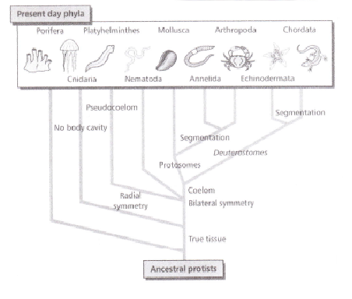

3.1.1 Which group were the ancestors of the animal kingdom? (2)

3.1.2 How many animal phyla are shown in this tree? (1)

3.1.3 The first major split in the animal kingdom was into radial and bilateral symmetry.

(a) Which phylum does not form part of this split? (1)

(b) Which phylum has radial symmetry? (1)

3.1.4 The second split is animals which have a coelom and animals which lack a body cavity.

1. Which phylum has no body cavity? (1)
2. Which phylum has a pseudocoelom? (1)

3.1.5 Of the animals which have a true body cavity, name the THREE phyla which have body segmentation. (3)

**(10)**

3.2 What is a through gut? What are the advantages of a through gut? (8)

3.3 Of what value are earthworms? (2)

3.4 Read the extract below and answer the questions that follow.

Despite a great increase in the demand for food, only 7% more land is now used for farming.

One of the reasons for this is increased productivity that is a higher yield per hectare, due to GMOs as well as the use of chemicals.

In the last 30 years, people have become more aware of the use of chemicals in farming.

Some people are concerned about the effects of these chemicals on their health and choose to buy organically grown produce. Farmers who use organic methods to produce food do not use chemicals on their crops.

3.4.1 Give ONE reason for an increase in the demand for food over the years. (1)

3.4.2 State ONE way in which the use of the following helps to increase productivity:

(a) Pesticides (1) (b) Fertilisers (1)

3.4.3 How does the use of pesticides destroy the food chains? (2)

3.4.4 Explain the term GMO (Genetic Modification) food. (3) **(8)**

3.5 Read the extract given below and answer the questions that follow.

Ozone is found at low concentrations 15-50 km above the Earth’s surface in the stratosphere.

Measurements show that there is a significant decrease in the amount of ozone. It has been observed that there are holes in the ozone layer which get bigger each year.

The main chemical responsible for the depletion of the ozone layer is chlorine,which comes from the breakdown of CFCs (chloroflouro-carbons). The CFCs are broken down by sunlight into chlorine atoms which then react with the ozone. Ozone is destroyed in this reaction. The problem is worse in the Polar Regions because of the low temperatures.

An investigation was carried out to measure the ozone concentration and the chlorine levels in Antarctica since 1950. The results are shown in the graph below:

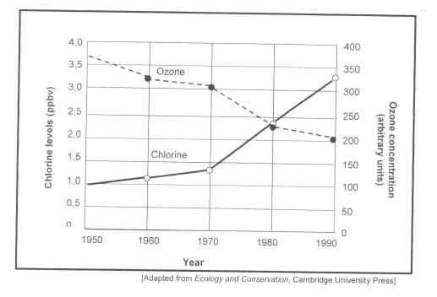

3.5.1 Give a caption (heading) for the graph. (2)

3.5.2 What is the relationship between the levels of chlorine and the concentration of

ozone? (2)

3.5.3 Name the dependent variable(s) in the investigation. (2)

3.5.4 In which 10-year period was the ozone depletion the greatest? (1)

3.5.5 In 1987 the Montreal Protocol was signed to lay down targets to reduce

the use of CFCs by countries. Give TWO reasons why, despite a reduction

in the use of CFCs, there was a decline in the ozone layer. (2)

3.5.6 Name ONE item that humans were using which contained CFCs. (1)

3.5.7 Explain why the ozone layer is important for humans. (2)

**TOTAL: 40**

**SECTION C**

**QUESTION 4**

It is increasingly likely that hundreds of millions of people will be displaced from their homes in the near future as a result of global warming. That is the warning of **economist and climate change expert Lord Stern** following the news last week that concentrations of carbon dioxide in our atmosphere had reached a level of 400 parts per million.

Robin McKie,Science Editor , The Observer, Sunday 12 May ,2013

Discuss how the enhanced greenhouse effect is brought about and how it causes global warming. Also refer to carbon dioxide and methane emissions as the main contributing factors.

**NOTE: No marks** will be awarded for answers in the form of a flow chart of diagram.

Content:( 17)

Synthesis: (3)

**(20)**

**GRAND TOTAL 150**