SESSION NO: 15
CONSOLIDATION: GENETICS (Paper 2)

SECTION A: TYPICAL EXAM QUESTIONS

QUESTION 1: 5 Minutes (Taken from various sources)
Various possible options are provided as answers to the following questions. Choose the answer and write only the letter (A – D) next to the question number.

1.1 | The inheritance of one trait does not depend on the inheritance of another trait. This represents …

 | A  B  C  D | the law of dominance.  the law of co dominance.  the principle of variation.  Mendel's principle of independent assortment.

1.2 | In mice, the genotype yy produces grey fur and Yy produces yellow fur. The genotype YY results in death during the early embryonic stages.  A yellow female mouse is mated with a yellow male mouse. Which of the following shows the correct ratio of yellow to grey offspring that could be born alive?

 | A  B  C  D | 1 : 1  1 : 3  2 : 1  3 : 1

1.3 | The diagram below shows the blood types of two parents.

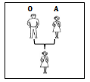
 | The only possible blood type(s) of the offspring of the first generation (F₁) is/are:
 | A  B  C  D | AB and O.  A and O.  A only.  A and B.

1.4 | Which one of the following monohybrid crosses will result in a phenotypic ratio of 1:1? A cross where…

 | A  B  C  D | both parents are heterozygous  both parents are homozygous for the dominant characteristic  one parent is heterozygous and the other parent is homozygous recessive  one parent is heterozygous and the other parent is homozygous dominant
1.5 | Four different phenotypes are possible in the F₁ generation if  the parents' blood groups are ...
 | A  B  C  D | B and B  A and B  O and AB  AB and AB

1.6 | 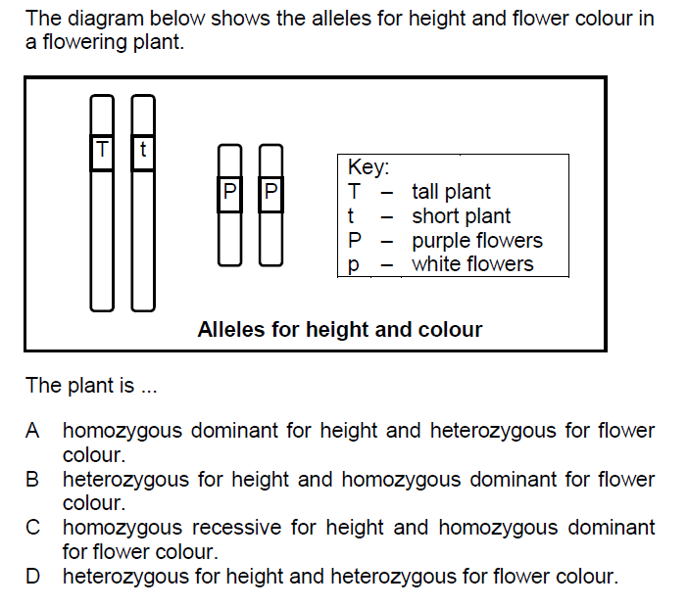

1.7 | In a monohybrid cross, the genotype of all the F₁ plants is Aa. If the F₁ plants are crossed, what percentage of the F₂ generation will have the dominant phenotype?

 | A  B  C  D | 25  50  75  100 (7x2) |  | (14)

QUESTION 1.2: 5 Minutes (Taken from various sources of Paper 2)
Give the correct biological term for each of the following descriptions. Write only the term next to the question number.
1.2.1  1.2.2  1.2.3  1.2.4  1.2.5  1.2.6  1.2.7  1.2.8  1.2.9 | The type of inheritance where the dominant allele masks the expression of the recessive allele in the heterozygous condition.  The process by which genetically identical organisms are formed using biotechnology.  The position of a gene on a chromosome.  The type of variation in a population with no intermediate phenotypes.  The physical or functional expression of a gene.  Chromosomes that carry same set of genes.  Two or more alternative forms of a gene at the same locus.  A genetic cross involving two characteristics.  A genetic disorder characterized by the absence of a blood-clotting factor.
1.2.10  1.2.11  1.2.12  1.2.13  1.2.14  1.2.15 | The type of inheritance involving two alleles of a gene that are not dominant over one other  Characteristics controlled by genes which are located on the sex chromosomes  Chromosomes that are similar in structure and code for the same characteristics  The type of inheritance involving alleles that equally determine the phenotype of heterozygous offspring  An allele that is expressed phenotypically only in the homozygous condition  A genetic cross involving one characteristic only
 |  |  | (15)

QUESTION 1.3 (Taken from various sources of paper 2)
Indicate whether each of the statements in COLUMN I applies to A ONLY,
B ONLY, BOTH A AND B or NONE of the items in COLUMN II. Write A only, B only, both A and B, or none next to the question number (1.3.1 to 1.3.4) in the ANSWER BOOK.
 | COLUMN I | COLUMN II
1.3.1 | Influences the inheritance of blood groups | - Codominance  - Multiple allele
1.3.2 | Chromosomes having the same shape, size and carrying similar genetic information | - Daughter chromosomes  - Homologous chromosomes
1.3.3 | Sudden change in the genetic makeup of an organism | - Contraception  - Mutation
1.3.4 | The genotype of blood group AB | - I^{A}i  - I^{B}i
1.3.5 | The physical and functional expression of a gene | - Phenotype  - Genotype
 |  |  | (5X2)
 |  |  | (10)

QUESTION 1.4: 5 Minutes (Taken from DBE Nov 2014, Paper 2)
About 70% of people get a bitter taste when a substance called PTC is placed
on their tongue. They are referred to as 'tasters'. All other people are unable to
taste PTC and are referred to as 'taste-blind'. The 'taster' allele is dominant and
the 'taste-blind' allele is recessive.

Also in humans, normal skin pigmentation is dominant to the albino condition (no pigmentation).

The letters in the key below must be used to represent the alleles for the
different characteristics above.

Key:

T – taster
t – taste-blind
N – normal skin pigmentation
n – no skin pigmentation (albino)

A man who is heterozygous for both tasting PTC and skin pigmentation marries
a woman who is taste-blind for PTC and is an albino.

    - State why the example above represents a dihybrid cross. (1)

    - Write down:

- The genotype of the woman (1)
- ALL the possible gametes of the man (2)

    - The man and woman have a child whose genotype is ttNn. What is the
child's phenotype? (2)

(6)

QUESTION 2: 10 Minutes (Taken from DBE Nov 2015, Paper 2)
A lack of immunity to infections (agammaglobulinemia) is a sex-linked recessive genetic disorder in humans. The dominant allele is represented by X^{A} and the recessive allele is represented by Xª.

An individual with the disorder is described as affected and an individual without it is described as unaffected. The pedigree diagram below illustrates inheritance of this disorder.

 | 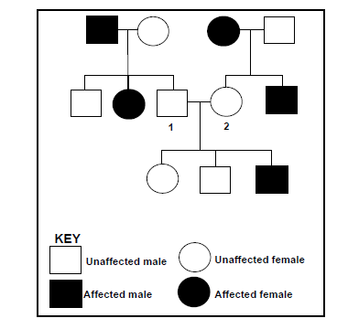
2.1 | Name the genotypes of individuals:  (a) 1  (b) 2 | (2)  (2)

QUESTION 3: 8 Minutes (Taken from FS Sept 2015, Paper 2)
The structure on the head (the comb) of chickens can be of different shapes. The diagram below shows the inheritance of two different shapes of comb, 'walnut' and 'pea'.
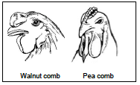
Walnut comb (W) is dominant over pea comb (w). In these chickens yellow legs (Y) are dominant over white legs (y).

Parent 1 is homozygous dominant for comb shape and heterozygous for colour of legs while parent 2 is homozygous recessive for comb shape and homozygous recessive for colour of legs.

3.1  3.2 | Write down:  - The genotype of parent 2  (b) The possible gametes of parent 1  The parents have an offspring with a genotype wwYy. What is the offspring's phenotype? | (2)  (2)  (2)  [6]

QUESTION 4: 6 Minutes (Taken from FS Sept 2015, Paper 2)
People with albinism are unable to produce the dark pigment, melanin, in their skin. This condition is caused when an individual is homozygous recessive to this characteristic.

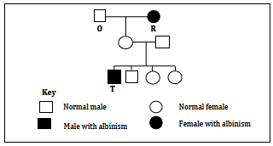

4.1 |  | Indicate whether each of the individuals below could be homozygous dominant, homozygous recessive or heterozygous:
 | (a)  (b) |  | O  T |  |  | (2)  (1)
4.2 |  | Explain your answer to QUESTION 4.1(a). |  |  |  | (3)  [6]

QUESTION 5: 7 Minutes (Taken from NW Sept 2015, Paper 2)
A person with blood group A marries a person with blood group B. Use a complete
genetic crossing to show that it is possible that all four blood groups can be present
in the offspring in one family. [7]

QUESTION 6: 6 Minutes (Taken from DBE Feb 2016, Paper 2)
The pedigree diagram below shows the pattern of inheritance of a certain genetic disorder controlled by a recessive allele. The dominant allele is represented by N and the recessive allele by n.

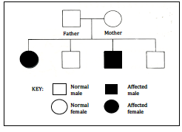
6.1  6.2 | Explain why both parents must be heterozygous for this characteristic.  Give the possible genotype(s) of the normal children. |  | (2)  (2)
6.3 | Provide evidence from the pedigree diagram to show that this characteristic is not sex-linked. |  | (2)  [6]

SECTION C: HOMEWORK QUESTIONS

QUESTION 1: 8 Minutes (Taken from Gauteng June 2014)
In humans, blood groups are controlled by multiple alleles.

1.1  1.2 | How many alleles control blood groups?  Mr Sparrow has blood group A and Mrs Sparrow has blood group B. They are both heterozygous.  Use a genetics diagram to show all the possible blood groups in their children.  Show the percentage probabilities of each genotype and each phenotype in the F₁ generation |  | (1)  (7)  [8]

QUESTION 2: 10 Minutes (Taken from Gauteng June 2014)

Colour-blindness in humans is caused by a recessive allele (b) and is carried on the X-chromosome. The pedigree diagram below shows the inheritance pattern of this disorder in the Bean family.

Study the pedigree diagram below and answer the questions that follow.

2.1  2.2  2.3 | What is a sex-linked disorder?  Provide the phenotypes for the following individuals:  a) Kofi and  b) Jeli  Give the genotypes of:  a) Mrs Bean and  b) Coco |  | (1)  (2)  (2)  [5]

QUESTION 3: 10 Minutes (Taken from DBE Feb 2016, Paper 2)
 | The size and colour of unripe fruit in a plant species is genetically controlled. The allele for small fruit (b) is recessive to the allele for big fruit (B). The allele for yellow fruit colour (g) is recessive to the allele for green fruit (G).
3.1 | State:
 | (a)  (b) | The phenotype of the plant with the genotype BbGg  ALL possible genotypes of the gametes produced by the plant mentioned in QUESTION 3.1(a) | (2)  (2)  [4]

QUESTION 4
(Taken from Nov 2015 Back-Up, Paper 2)
4.1 | In guinea pigs the allele for a black coat colour (B) is dominant over the allele for a white coat colour (b). The allele for a rough coat texture (R) is dominant over the allele for a smooth coat texture (r).  A male guinea pig which is homozygous dominant for coat colour and heterozygous for coat texture was mated with a white female guinea pig that is heterozygous for coat texture

4.1.1  4.1.2  4.1.3 | How many characteristics of the guinea pigs are being investigated?  Give the possible gametes of the female guinea pig.  Two of the offspring of the F1-generation were crossed. The genotypes of their offspring are represented in the Punnett square below, except at (i) and (ii).  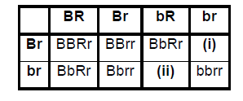 | (1)  (2)

Give the:
 | (a)  (b)  (c) | Genotype of the offspring at (i)  Phenotype of the offspring at (ii)  Phenotypic ratio of all the offspring | (1)  (1)  (2)

QUESTION 5 (Taken from DBE Nov 2014, Paper 2)
 | The pedigree diagram below shows the inheritance of haemophilia in a family.
 | The allele causing haemophilia is represented by X^{h} and the normal allele is represented by X^{H}.
1

2

3

4

5

6

7

8

9

10

11

12

13

14

I
nheritance of haemophilia

Normal male

Haemophi
iliac male

Haemophiliac

female

Normal female

Key:

5.1 | Determine the following:  - Phenotype of individual 4  - Genotype of individual 2 | (1)  (2)
5.2 | Explain why this disorder affects more males than females | (3)

  - QUESTION 6
 | In apples red colour is dominant over yellow colour. Use R to show the dominant characteristic and r to show the recessive characteristic
6.1 | A farmer crossed heterozygous red apple trees with homozygous yellow apple trees. Using the punnet square below, work out the genotype and phenotype of F_{1.}  R r  r  r | (6)
6.2 | What percentage of F ₁ will be yellow apple trees ? | (1)

