AHMED TIMOL SECONDARY
LIFE SCIENCES
GRADE 11
JUNE 2013 * 90 minutes * 120 marks

EXAMINER: A.RAJAH
MODERATORS: MR M.A. KHAN and N.F. MAXIMILIAN
INSTRUCTIONS: Answer all questions on the writing material provided. Number the answers correctly according to the numbering system used in this question paper. Write neatly and legibly using a blue pen.
QUESTION 1
1.1 Various options are provided as possible answers to the following questions. Choose the correct answer and write only the letter (A to D) next to the question number (1.1.1 to 1.1.9) in your ANSWER BOOK, for example 1.1.12 D.
1.1.1 Viruses are …
A) the only disease causing organisms.
B) the only parasitic microorganism.
C) the only acellular microorganism.
D) the only eukaryotic organism.
1.1.2 Which of the following is not a shape of bacteria?
A) Coccus.
B) Bacillus.
C) Spirogyra.
D) Vibrio.
1.1.3 Which of the following is used to show that photosynthesis has occurred in a leaf?
A) Iodine solution.
B) Benedict’s solution.
C) Millons reagent.
D) Sunlight.

1.1.4 Which plant group has a dominant gametophyte generation?
A) Bryophytes.
B) Pteridophytes.
C) Gymnosperms.
D) Angiosperms.
1.1.5 Which of the following is a product of photosynthesis?
A) Water.
B) Chlorophyll.
C) Enzymes.
D) Oxygen.
1.1.6 Pancreatic juice does NOT contain….
A) Carbohydrases.
B) Proteases.
C) Lipases.
D) Insulin.
1.1.7 Cellular respiration takes place in…
A) Chloroplasts.
B) Mitochondria.
C) Nucleus.
D) Ribosome.
1.1.8 Glucose is split into pyruvic acid during…
A) Glycolysis.
B) Krebs cycle.
C) Oxidative Phosphorylation.
D) Photosynthesis. 2X8 =16
1.2 Give the correct biological term for each of the following descriptions. Write only the term next to the question number (1.2.1–1.2.8) on the ANSWER SHEET.
1.2.1 Plants that bear seeds on cones.
1.2.2 Organisms with a coelom lined by mesoderm on one side only.
1.2.3 The phenomenon whereby pathogenic microorganisms are no longer affected by drugs.
1.2.4 A whip-like tail used by bacteria and protists for locomotion.
1.2.5 A faster form of reproduction where offspring produced are genetically identical.
1.2.6 A state where the top surface of an organism is different from the lower surface.
1.2.7 Part of the chloroplast wherein the dark phase occurs.
1.2.8 A building wherein plants are given optimum conditions for photosynthesis. 1X8=8
1.3 Indicate whether each of the descriptions in COLUMN I applies to A ONLY, B ONLY, BOTH A AND B or NONE of the items in COLUMN II. Write A ONLY, B ONLY, BOTH A and B, or NONE next to the question number (1.3.1–1.3.8) on the ANSWER SHEET.
 | COLUMN I | COLUMN II
1.3.1 | Bread mould | A: | Fungus
 |  | B: | Protista
1.3.2 | Used to make cheese | A: | Fungus
 |  | B: | Bacteria
1.3.3 | Capable of photosynthesis | A: | Plants
 |  | B: | Bacteria
1.3.4 | Has seeds | A: | Bryophytes
 |  | B: | Pteridophytes
1.3.5 | Energy molecule | A: | Chlorophyll
 |  | B: | ATP
1.3.6 | Radially symmetrical | A: | Porifera
 |  | B: | Cnidera
1.3.7 | Function of the villi | A: | Increase surface area
 |  | B: | Absorb nutrients
1.3.8 | Psychological eating disorder | A: | Anorexia
 |  | B: | Bulimia
8X2=16
TOTAL QUESTION 1: 40

QUESTION 2
2.1 The following is an abstract of a research paper on the effect of providing nutrition for school going children. Read the abstract and answer the questions that follow.
Minnesota's Fast Break to Learning Breakfast Program
“Fast Break to Learning” is a report of the First-Year Results of the Fast Break to Learning School Breakfast Program by the Minnesota Department of Children, Families, and Learning, where breakfast was offered to all students, at little or no charge and often served after the school day started, either in the classroom or the cafeteria. Excellent results were reported.
- On 3 out of 4 reading and math tests on the Minnesota Comprehensive Assessment Test (MCAT) 3rd and 5th graders in Fast Break to Learning schools improved academic achievement more than the control group of schools
- 97% of principals strongly agreed or agreed their school benefited from the program, with decreased negative behaviour and tardiness (slowness to react) as the top benefits mentioned
http://school.fueluptoplay60.com

2.1.1 Where was this study conducted? (1)
2.1.2 What fraction of learners had improved reading and math test results? (1)
2.1.3 What percentage of principals think that the programme did not benefit their schools? (2)
2.1.4 Learners in the programme performed better that “the control group”. Describe the condition of the control group. (2)
2.1.5 One of the researchers put forward the following hypothesis. “Providing breakfast might improve results and behaviour.”
State whether the hypothesis is correctly stated or not. If correctly stated give a reason for your answer, if incorrectly stated, correct the hypothesis. (3)
2.1.6 Predict ONE reason why the South African government might not be willing to start a similar project in all South African schools. (2)
[11]
2.2 The diagram below shows a diagram of the human digestive system.

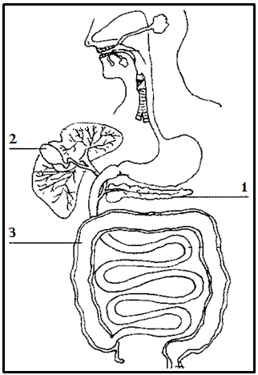Diagram of the human digestive system.
2.2.1 Label part numbered 1. 1
2.2.2 Name the substance stored at part numbered 2. 1
2.2.3 State ONE function of part numbered 3. 1
2.2.4 Distinguish between the function of the cardiac sphincter and the pyloric sphincter of the stomach. 2
2.2.5 Mohammed hangs upside-down from a tree. He chews on a grape and swallows it. He also takes a sip of his sister’s juice. Suggest a reason why the food did not come out of his mouth due to gravitational forces. 2
[7]

2.3 The following diagram is a cross section through an earthworm
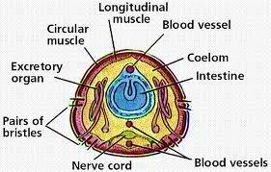
Above: Drawing of a cross-section through an earthworm.
2.3.1 To which phylum do earthworms belong? (1)
2.3.2 Describe the Earthworm with regard to the following features:
a) symmetry
b) number of tissue layers
c) type of digestive system
d) coelom (4X1=4)
2.3.3 The blood vessels shown in the diagram are absent in flatworms such as planaria. Account for this difference. (3)
2.3.4 Explain how Earthworms are important for agriculture and in ecosystems. (4)
[12]
TOTAL QUESTION 2: 30

QUESTION 3
3.1 The diagram shows a salvia flower. Look at it carefully and answer the questions.
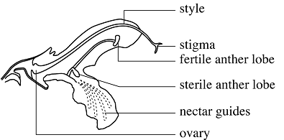
Left: diagram showing the flower of a salvia plant.
3.1.1 Why is this plant classified as an angiosperm? (1)
3.1.2 Define pollination (1)
3.1.3 Name the method of pollination used by this plant. (2)
3.1.4 Give the function of the fertile anther lobe. (1)
3.1.5 In which part of the flower does the seed develop? (1)
[6]
3.2 The following diagram shows the apparatus used in an experiment. Seeds of the pea plant were soaked in water and placed into 3 identical glass bottles. A fourth empty bottle was also used. A Carbon dioxide sensor was placed into each of the bottles. One bottle with seeds was place into the freezer, another in a room and the third in the oven. Answer the questions that follow.
Left: diagram showing the apparatus used in order to measure the quantity of CO₂.
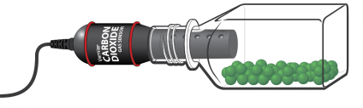
3.2.1 What process is being investigated in this experiment? (1)
3.2.2 Write down an aim for this experiment (2)
3.2.3 Is light necessary for this process? (1)
3.2.4 Why was one bottle left empty (without seeds?) (1)
3.2.5. Why was it necessary to soak the seeds in water? (1)
3.2.6. The table below indicates the results of the experiment. Use this data to draw a graph.
CONDITION | AMOUNT OF CO2 IN AIR (%)
No seeds | 0.03
Freezer | 0.04
Room temperature | 0.1
Oven | 0.03
(10)
[16]
3.3 The following are statements by people about HIV/AIDS
Person A “Stay away from people with AIDS, you will get infected if they sneeze near you.”
Person B “All people with HIV are either gay or were sleeping around so they deserve to suffer”
Person C “I’m not worried about getting HIV new drugs will keep me well”
Person D “I’m HIV positive ….. my life is over”
Using the scientific knowledge that you have gained on the causes, prevention and treatment of HIV, state why the views expressed by each of the individuals above are incorrect. (2 X4 =8)
TOTAL QUESTION 3: 30
QUESTION 4
Algae, Bryophytes, Pteridophytes, Gymnosperms, Angiosperms and some bacteria share a common process of manufacturing organic compounds. These compounds are used by organisms of all other trophic levels. Describe this process of producing organic compounds in detail. Also name the kingdoms that would consume these compounds.
NOTE: NO marks will be awarded for answers in the form of flow charts or diagrams.
CONTENT 17
SYNTHESIS 3
[20] TOTAL QUESTION 4: 20 GRAND TOTAL : 120

