

AHMED TIMOL SECONDARY

**LIFE SCIENCES**

EXAMINER: A. Rajah

MODERATORS: N. F. Maximilian & M. A. Khan

Marks: 150 Time: 2 Hours

**GRADE 11**

**PAPER 2**

**NOVEMBER 2013**

**NOVEMBER 2011**

**THIS QUESTION PAPER CONSISTS OF 10 PAGES**

INSTRUCTIONS AND INFORMATION

1. Answer ALL questions on the writing material provided.
2. Write neatly using a blue pen.
3. Rule off after each question.
4. ALL drawings should be done in pencil and labelled in blue ink.
5. Only draw diagrams or flow charts when requested to do so.
6. If answers are NOT presented according to the instructions of each question, you will lose marks.

**QUESTION 1**

* 1. Various options are provided as possible answers to the following questions. Choose the correct answer and write only the letter (A to D) next to the question number (1.1.1 to 1.1.9) in your ANSWER BOOK,

for example 1.1.12 D.

* + 1. Which of the following is true about viruses?

1. Viruses are made of only one cell.
2. Viruses are larger than bacteria.
3. All viruses are parasitic.
4. All viruses only contain RNA.
   * 1. Plants from the bryophyte group have ...
5. well-developed conducting and strengthening tissue, rhizoids andreproduce by means of spores.
6. poorly developed conducting and strengthening tissue, roots andreproduce by means of spores.
7. poorly developed conducting and strengthening tissue, rhizoids andreproduce by means of spores.
8. poorly developed conducting and strengthening tissue, rhizoids andreproduce by means of seeds.
   * 1. Diploblastic organisms have the following tissue layers.
9. Endoderm and ectoderm.
10. Endoderm and mesoderm.
11. Mesoderm and ectoderm.
12. Endoderm, mesoderm and ectoderm.
    * 1. Accumulation of sense organs at one end of the body:
13. Dorso-ventrally differentiated.
14. Triploblastic.
15. Psuedocoelomate.
16. Cephalisation.
    * 1. The role of pesticidesis to...
17. cause pests to grow.
18. kill pests.
19. cause plants to grow.
20. kill plants.
    * 1. Benefit of using the hoodia plant:
21. Boosts the immune system.
22. It is a source of caffine.
23. It is an appetite suppressant.
24. Eases joint pain.
    * 1. Controlling an alien species using another organism:
25. Biological control.
26. Mechanical control.
27. Chemical control.
28. Organismal control.
    * 1. An ecological footprint can be defined as....
29. the biotic and abiotic interactions in an ecosystem.
30. the amount of carbon dioxide released by an organism.
31. all the living organisms in an ecosystem.
32. human demands on the natural resources of the environment.

1.1.9 Which ONE of the following represents a positive human impact on the environment?

1. Pollution.
2. Conservation.
3. Environmental degradation.
4. Population explosion. (2X9=18)

1.2 Give the correct biological term for each of the following descriptions. Write only the term next to the question number (1.2.1–1.2.8) on the ANSWER\ SHEET.

1.2.1 Disease caused by the *plasmodium* parasite.

1.2.2 Plant group that bears seeds on cones.

1.2.3 Plant group with a dominant gametophyte generation.

1.2.4 Plants without conducting tissue.

1.2.5 Group of angiosperms with flowers made of four whorls and parts in multiples of 2 or 5.

1.2.6 Type of skeleton found on the outside of the organisms’ bodies.

1.2.7 The cultivation of a single plant species.

1.2.8 Fuels derived from the compacted remains of organisms that lived in the past.

(1X8=8)

1.3 Indicate whether each of the descriptions in COLUMN I applies to A ONLY, B ONLY, BOTH A AND B or NONE of the items in COLUMN II. Write AONLY, B ONLY, BOTH A and B, or NONE next to the question number (1.3.1–1.3.8) on the ANSWER SHEET.

|  |  |  |  |
| --- | --- | --- | --- |
|  | COLUMN A |  | COLUMN B |
| 1.3.1 | A unicellular eukaryote. | A | Protista |
|  |  | B | Monera |
| 1.3.2 | Reproduce by means of seeds. | A | Angiosperms |
|  |  | B | Gymnosperms |
| 1.3.3 | Depend on water for sexual reproduction. | A | Bryophytes |
|  |  | B | Pteridophytes |
| 1.3.4 | Liverworts are part of the group. | A | Pteridophytes |
|  |  | B | Gymnosperms |
| 1.3.5 | Porifera. | A | Acoelomate |
|  |  | B | Assymmetrical |
| 1.3.6 | Affected by poaching. | A | Rhino |
|  |  | B | Elephant |
| 1.3.7 | Rooibos tea is made from… | A | Devils claw |
|  |  | B | African potato |
| 1.3.8 | Methane gas. | A | Greenhouse gas |
|  |  | B | Source of energy  2X8=16 |

1.4 Study the diagram below and answer the questions that follow.

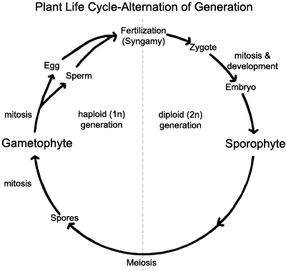

**E**

**C**

**A**

**B**

**D**

1.4.1 Provide the label for A. (1)

1.4.2 Provide the label for B. (1)

1.4.3 Name the cell division occurring at C. (1)

1.4.4 Will D be the male or female gamete? (1)

1.4.5 Name the cell represented by D. (1)

1.4.6 Name the cell division occurring at E. (1)

1.4.7 A moss plant has 10 chromosomes at D. How many chromosomes will be present in the zygote? (2)

**[8]**

**TOTAL QUESTION 1 50**

**QUESTION 2**

2.1 Analyse the diagrams below and answer the questions that follow. (Diagrams are NOT drawn to scale)



DIAGRAM 1 DIAGRAM 2

2.1.1 Name the group of plants that have the structures shown above. 1

2.1.2 Tabulate 3 visible differences between diagram 1 and diagram 2. 7

2.1.3 Name the process where pollen moves from the anther to the stigma. 1

2.1.4 Name the type off reproduction where there is no fusion of male and female gametes 1

**[10]**

2.2 Link the appropriate diagram/s with the statements below.

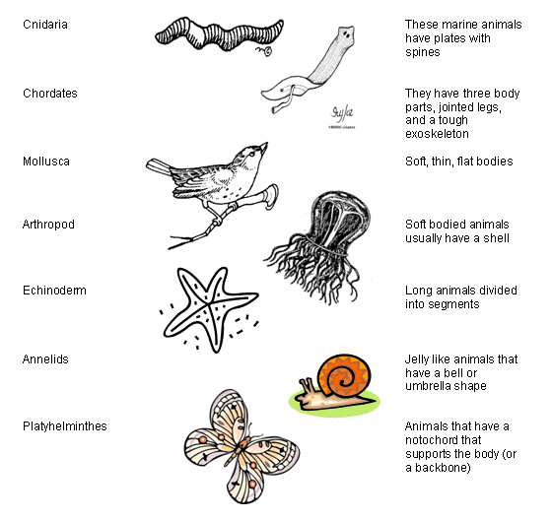

A B C

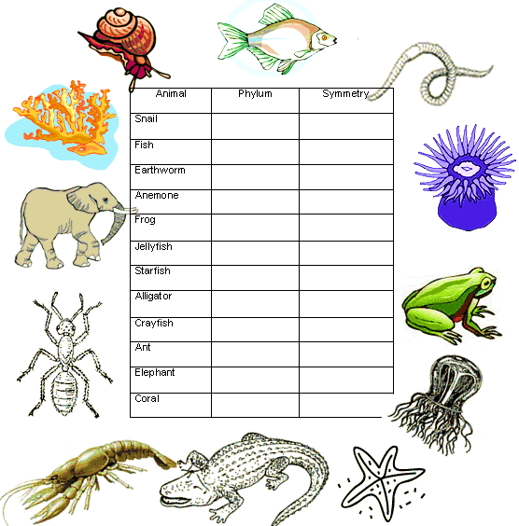 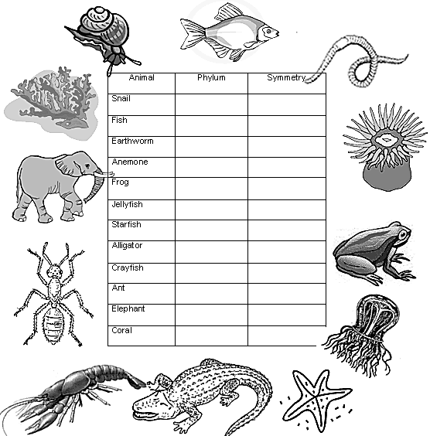

D E

Write down the **LETTER/S** next to the question number, of the organism/s that is/are:

2.2.1 radially symmetrical.

2.2.2 having a through gut.

2.2.3 diploblastic.

2.2.4 having an open blood system.

2.2.5 coelomate.

2.2.6 triploblastic.

**[13]**

2.3 The following graph represents the lactation curve of a cow in the herd that suffered from a common bacterial disease.

2.3.1 Use the graph to create a table showing the data. (5)

2.3.2 In this investigation, what is the dependant variable? (1)

2.3.3 How did the farmer know that this cow had an illness? (2)

2.3.4 What would indicate that the infection was treated successfully? (2)

2.3.5 Name the group of medications used to kill bacteria. (1)

2.3.6 Name the kingdom to which bacteria belong (1)

2.3.7 The farmer analysed the blood of the cow using a microscope to see for foreign particles.

i) At which week should he have taken a blood sample? (1)

ii) Name three shapes that bacteria occur in. (3)

2.3.8 After successfully using a particular treatment for over three years, the farmer noticed that thetreatment had stopped working for the same bacterial disease. Name this phenomenon. (1)

**[17]**

**TOTAL QUESTION 2 40**

**QUESTION 3**

3.1 Read the passage below and answer the questions that follow.

Freshwater in South Africa

South Africa is a chronically water stressed country with huge economic development pressures and social upliftment challenges.

Water availability is one of the most decisive factors that will affect the economic, social and environmental well-being of South Africa over the next decade, and its supply is already precariously limited.   
  
In the past, South Africa has invested heavily in water infrastructure and this is, in part, why the country has enjoyed a false sense of water security. However, the country is fast approaching full utilisation of available surface water yields, and running out of suitable sites for new dams.  
  
Water supply issues cannot be solved by simply building more dams or creating more infrastructure, but relies heavily on rehabilitating, maintaining and conserving the natural areas which form the critical catchments and “water factories” for the country. Furthermore, climate change models also predict significant changes to both rainfall and temperature in southern Africa, which will affect water storage negatively.  
  
South Africa needs to think innovatively about ways of reducing water demand and making water available, outside of the traditional engineering solutions of infrastructure development, if it wishes to sustain economic growth and maintain healthy freshwater ecosystems.

[http://www.wwf.org.za](http://www.wwf.org.za/)

3.1.1 Why do South Africans have a false sense of water security? (1)

3.1.2 State TWO ways from the article, in which people can reduce water demand. (2)

3.1.3 Climate change models predict negative “changes to both rainfall and temperature in southern Africa”. Describe how each of the following will change:

a) Rainfall

b) Temperature (2)

3.1.4 How do exotic/alien plants affect water supply? (3)

3.1.5 Farmers prefer sites near to natural water supplies.

a) Why would both crop and animal farmers prefer areas close to water? (2)

b) Explain how the use of excess fertilizers during farming can have a negative impact on water supplies. (4)

**[14]**

3.2 Study the data in the table below and answer the questions that follow.

Table: Urban waste composition in different parts of the world.

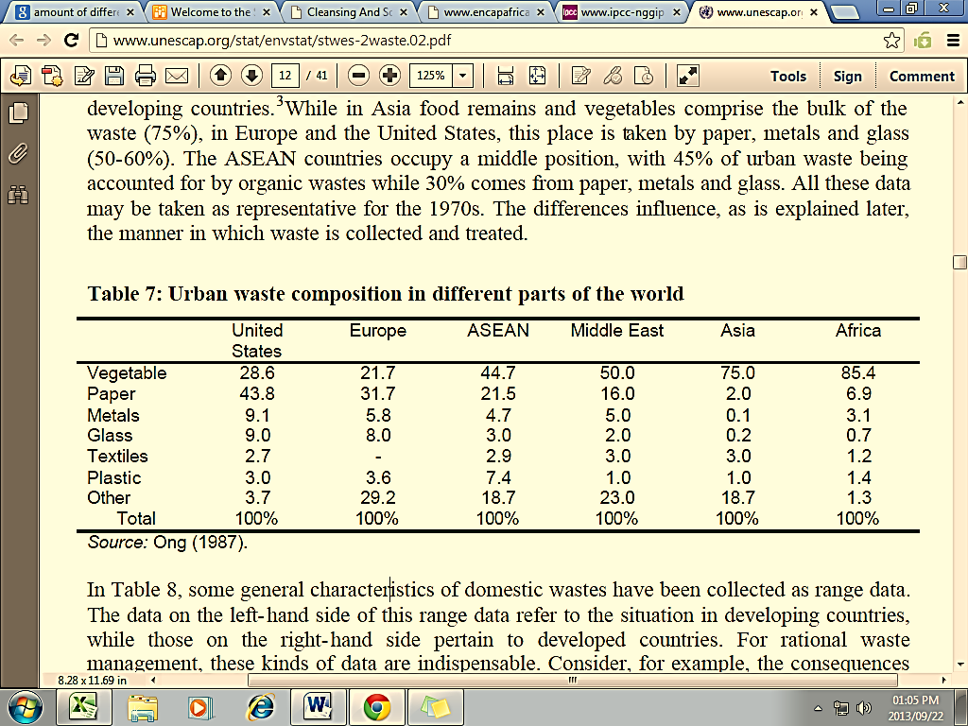

**X**

3.2.1 Which area produces the greatest amount of “other” waste? 1

3.2.2 Which solid waste is produced in the lowest quantity in Africa? 1

3.2.3 Draw a pie chart to show the percentage of waste that is made of PLASTIC for the different countries. 7

3.2.4 Calculate the percentage of waste paper (X) produced in Asia. Show all calculations. 3

3.2.5 A wise waste management strategy has the logo “reuse, reduce, recycle”. Differentiate between these words. 3

3.2.6 In which year was the information above reported? 1

3.2.7 Would you expect the values for Africa to be the same in 2013? Explain your answer. 2 **[18]**

3.3 Mushrooms are a healthy food option because they contain few calories, have nocholesterol and are fat- and salt-free. Mushrooms are also packed with healthy

minerals and vitamins.

3.3.1 If you wish to grow mushrooms, name TWO conditions that would favour fungal growth. (2)

3.3.2 How are the cells of fungi structurally similar to that of plants? (1)

3.3.3 How are the cells of fungi structurally different to that of plants? (1)

3.3.4 Apart from being a food source list two other ways that fungi are beneficial. (2)

3.3.5 Name TWO ways in which fungi have a negative impact on humans. (2)

**[8]**

**TOTAL QUESTION 3 40**

**QUESTION 4**

Global warming is primarily caused by changes in the Earth’s atmosphere. Describe the atmospheric changes that are occurring which cause global warming. Also list the impacts of global warming. CONTENT 17

SYNTHESIS 3

**(20)**

**NO marks will be awarded for answers in the form of flow charts or diagrams.**